A legendary combination
Sennheiser offers audiophile anniversary bundle of HD 820 & HDV 820

LONDON, 11 March 2020 – Sennheiser is celebrating its 75th anniversary in 2020! To celebrate with headphone fans around the world, the audio specialist combines the renowned closed dynamic HD 820 headphones with the HDV 820, the next generation digital headphone amplifier at 25% off. From March to end of June, this audiophile bundle is only available from Sennheiser Stores and the Sennheiser Online shop.

“This limited time promotion is a very special thank you to our audiophile customers around the world”, explains Stephane Hureau, Global Head of Products Consumer at Sennheiser. “The package offers an unparalleled listening experience for audiophiles who are sharing our passion for great audio – available at a special price to celebrate Sennheiser’s 75th anniversary.”

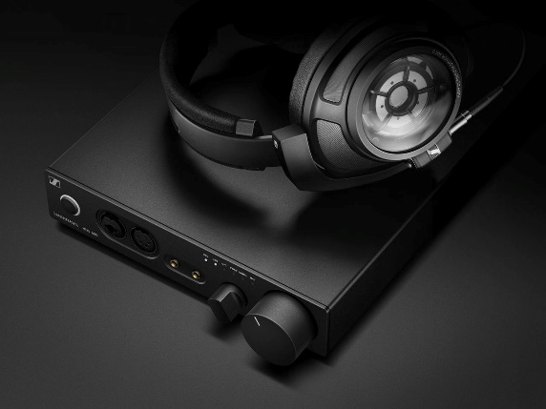 | The Sennheiser HD 820 and HDV 820 make a perfect bundle for audiophiles – available at a special price to celebrate Sennheiser’s 75th anniversary
The audiophile standard for closed-back headphones
The HD 820 closed dynamic headphones let passionate music lovers enjoy magic sound moments. By proving that closed back design headphones could deliver reference class sound, they epitomise the spirit of innovation that has defined Sennheiser’s 75-year history. Featuring unique glass transducer covers that minimise resonances, they offer a wide-open sound field that is breathtakingly transparent and natural. Made in Germany, the HD 820 stands out because of its extraordinary attention to detail: From the extra comfortable handcrafted ear pads that insulate the listener from ambient noise, to the silver coated OFC cables and gold-plated plugs, to the robust metal headband with an inner damping element.

The perfect partner for reference class headphones
Sennheiser’s HDV 820 is the next generation of its acclaimed digital headphones amplifier HDVD 800, designed to complete the Sennheiser audio experience and perfectly complement the HD 820 for the ultimate acoustic performance. The amplifier assures an adulterated listening enjoyment for every audio source and is powered by a high-quality ESS SABRE32 digital- to-analog converter. This delivers unequalled dynamic range, ultra-low distortion and unmatched audio clarity.

The audiophile anniversary bundle is available for 2,998 GBP from the beginning of March to the end of June in all Sennheiser Stores and the Sennheiser Online shop.

About Sennheiser
Founded in 1945, Sennheiser is celebrating its 75th anniversary this year. Shaping the future of audio and creating unique sound experiences for customers – this aim unites Sennheiser employees and partners worldwide. The independent family company, which is managed in the third generation by Dr. Andreas Sennheiser and Daniel Sennheiser, is today one of the world’s leading manufacturers of headphones, loudspeakers, microphones and wireless transmission systems. In 2018, the Sennheiser Group generated turnover totaling €710.7 million. www.sennheiser.com

North and East Europe Press Contact
Sennheiser electronic GmbH & Co. KG
Maik Robbe
Communications Manager UK & Nordics
maik.robbe@sennheiser.com

